Covid-19 Tracking Application

# Content

1.Introduction

1.1 Objective

1.2 Users & Intended Audience

2. Functional Requirements

3. Non-Functional Requirements

4. Frontend

5. Backend



**1.INTRODUCTION**

To build an application to connect essential health services with the people across the world to fight against COVID-19.

* 1. Objective

The application is aimed effectively to inform the users of the app regarding the risks, vaccination and relevant advisories pertaining to the containment of COVID-19.

1.2 Users & Intended Audience

* Government
* Public

**2. FUNCTIONAL REQUIREMENTS**

* To build an application such that the users can access information about the COVID-19 statistics
* The application should have signup, login, profile, dashboard page and individual records.
* The application should have individual data of users like

1. User_name
2. Country_name
3. State_name

* The application should have the location access so that it automatically operates with the current location of the user
* The application should display the following statistics

1. Confirmed cases
2. Deaths
3. Fatality Rate
4. Latitude
5. Longitude
6. Last Update

* The application should have a separate database to store individual information of the user, public information and COVID-19 statistics
* Encrypt the sensitive information
* It should be an integrated platform for the government and the public users
* The ranges like Death, confirmed cases can be given in graphical format
* Aadhar integration of the individual user and encryption
* Availability in different languages
* List of ICMR approved labs with COVID-19 testing facility.
* List of nearby vaccination centre.
* Report of COVID-19 vaccination stats

1. Total vaccination across the country
2. First dose vaccination
3. Second dose vaccination
4. Booster dose vaccination

* Emergency Helpline contact number
* Update user about nearby COVID positive cases using location service
* Information about containment zones, research, reports related COVID-19

**3. NON-FUNCTIONAL REQUIREMENTS**

SECURITY

* The app must have a privacy policy disclosure.
* Since it is related to COVID-19 it does not collect much personal information about the user apart from aadhar details but it should be encrypted.
* Apps must handle all personal or sensitive user data securely, including transmitting it using modern cryptography (for example, over HTTPS).

FEATURES

* No. of tested cases
* Confirmed cases
* Deaths in the country
* A heatmap of the largest concentrations of confirmed covid-19 cases
* Locations of public testing centres in the state
* No. of vaccination done
* First dose vaccination status
* Second dose vaccination status
* Booster dose status

LOGGING

The application should support logging of the user at all levels ( app, web, DB)

BROWSER USAGE

All latest browsers

TECHNOLOGY USED

* HTML&CSS
* Javascript

ASSUMPTION OF THE APPLICATION

1. The login page should be the first page rendered when the application is installed and opened
2. The details given in the login page

* Email id/ Mobile number
* Password

3. Unless logged into the system, the user cannot navigate to any other pages.

4. Logging out must again redirect to the login page

5. Admins can use the page using the admin dashboard

VERIFICATION

* The mail id given should be verified or the mobile number is verified

**USER**

The user will get the similar pages on the screen

Sample:

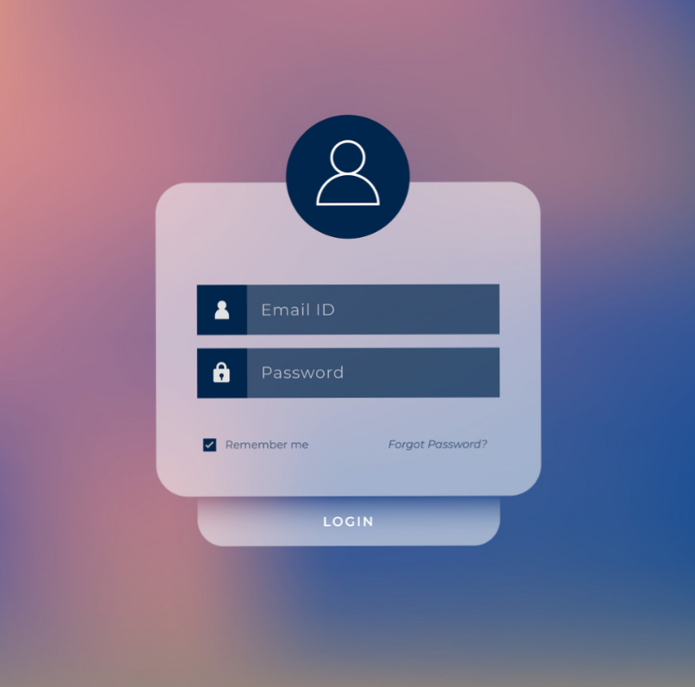

After logging in the user can access to information related to covid-19.

ADMIN LOGIN

Sample:

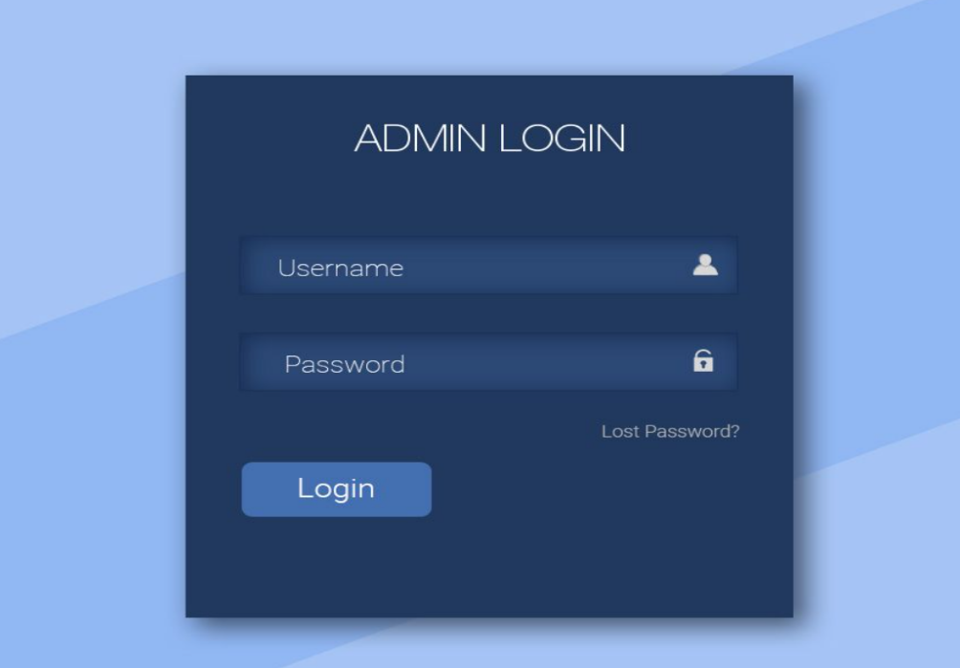

**4.FRONTEND**

USER

* The login page can be created using HTML/CSS
* In the sign-up page have following details
* Mail id/mobile number
* Aadhar number
* password
* confirm password
* submit Button
* Sign-in Link
* Sign-up Box
* In the login page have the following details
* Aadhar number
* Mail/id
* password
* Login Box
* Submit button

DASHBOARD /HOME PAGE

* User_navigation_bar
* Home button
* Personal data
* All stats about covid-19
* Log out button

Sample of dashboard /home page:

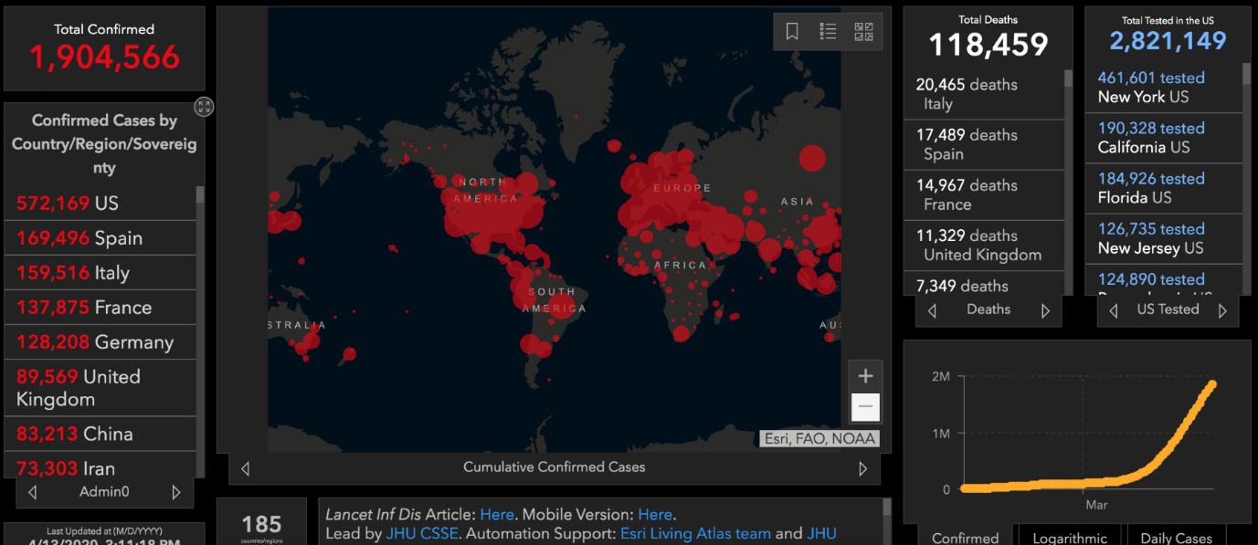

ADMIN:

* Admin page dashboard
* Admin_Nav_bar
* admin add Button
* admin confirm Button
* log-out Button

Sample Heatmap:

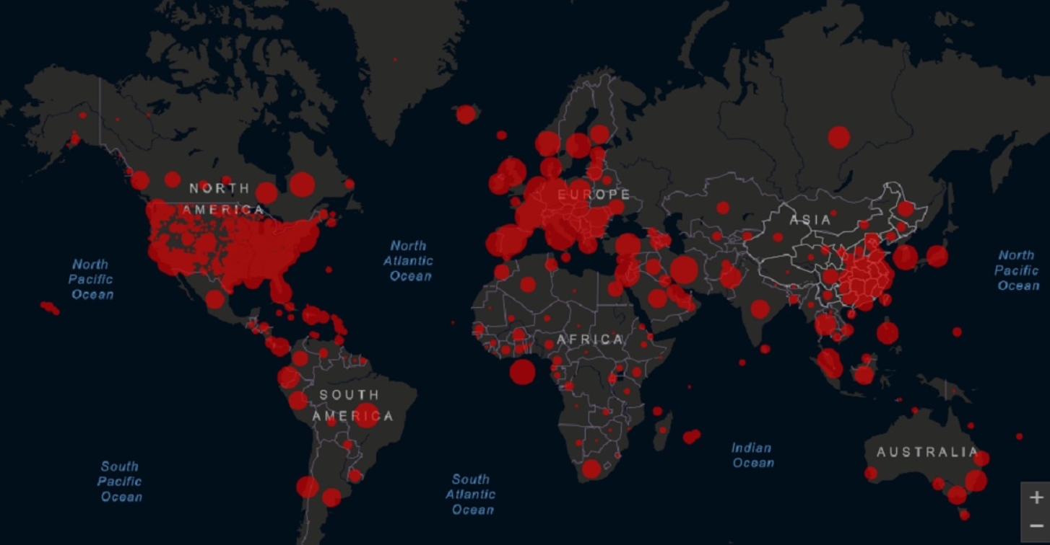

**5.BACKEND**

Model layer:

User Model

1. Attributes

* Mail id/mobile number- string
* Password-string
* Confirm password-string
* Aadhar number-string

Admin Model

1. Attributes

* Mail/id -string
* Password-string
* Username-string

Login Model: This class contains the email and password of the user.

a.   Attributes:

                   i.   Aadhar: String

                  ii.   password: String

 Covid 19 Model: This class stores the details of the patient.

a.   Attributes:

           i.   StateId: String

           ii.   imageUrl: String

       iii.   patient name: String

            iv.   Status: String

**THANK YOU!**

**SRS Document prepared by:**

* **Jayasrini.R**
* **Kaviya Sri.R**
* **Geethanayagi.V**
* **Boomika.E**